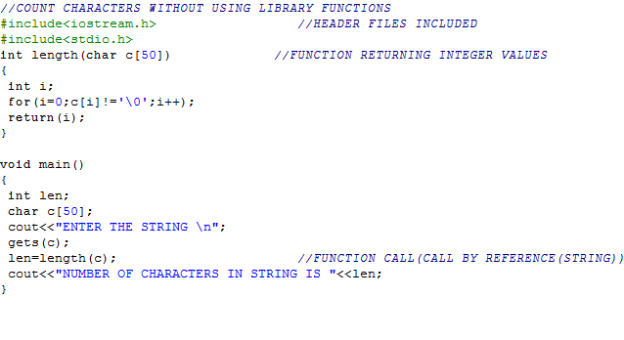

**OUTPUT:**

F:\c++ 12 th file\madhur\MADHUR\MADHUR\c++  file MADHUR 12\10B\Capture.PNG